Achievement for the mon th of march from electrical dept

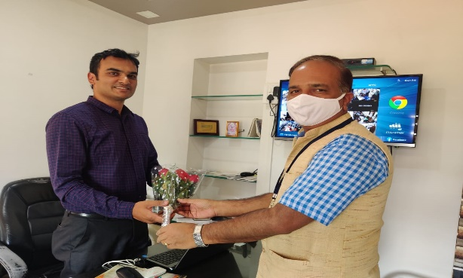
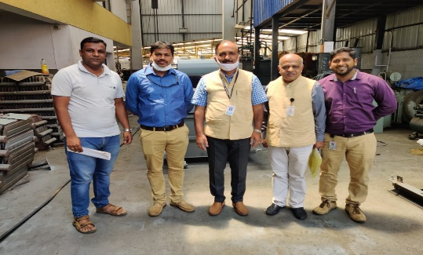

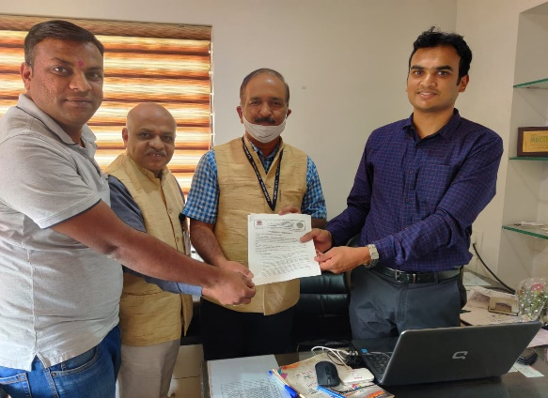

VDIT signed MOU with Shri. Siddhi Vinayaka Transformers, Belagavi, on 20/3/21 ,who work on Core Design of Industrial Transformers. This will help our students of E&E, Mechanical Engineering in exposing to Industrial Atmosphere. Several Field Visits & Internship Program has been planned.

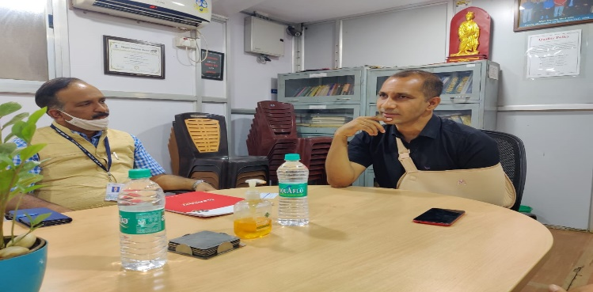
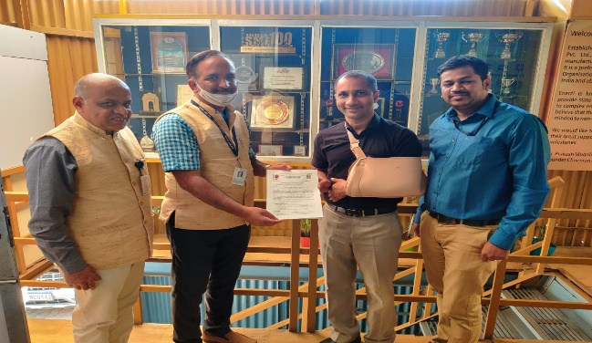

VDIT has signed MOU with ENERZI SYSTEMS, BELAGAVI ,on 20/3/21, it will empower students to attend internship with Core companies and will create job opportunities.

Project entitled is selected for scholarship worth 6000/- by KSCST under “44th Series of Student Project Programme: 2020-21”
Title of the project: IoT Based Efficiency Monitoring System for Domestic Bio-Gas Plant
Name of students:
Jyothi N. Khanapur 2VD17EE013
Prashasti G. Divate 2VD17EE024
Shreya A. Jadhav 2VD17EE031
Prakash P. Kammar 2VD18EE404
Guides:
Prof. Kirankumar N. Hittanagi
Prof. Ravindra Motekar

