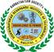 | KARNATAK LAW SOCIETY’S  Vishwanathrao Deshpande Institute of Technology
 | Doc. No.: | Rev.No.:01
 | Page 1 | Rev. Dt: 19/06/2021
 | Report on staff and student achievements from Department
Report on Events Organized by EEE Department
(December-2021)
1. Department of Electrical and Electronics in association with Department of Library and Information Centre organized “Awareness Program on National Digital Library of India (NDLI)” on 10th December 2021. Mr. Sunil Yaragatti, Librarian, KLS VDIT was the resource person of this talk. Faculty and students of all semesters attended this program and gained the knowledge about unique features of NDLI and how to access it. Prof. Kirankumar Hittanagi co-ordinated the event.

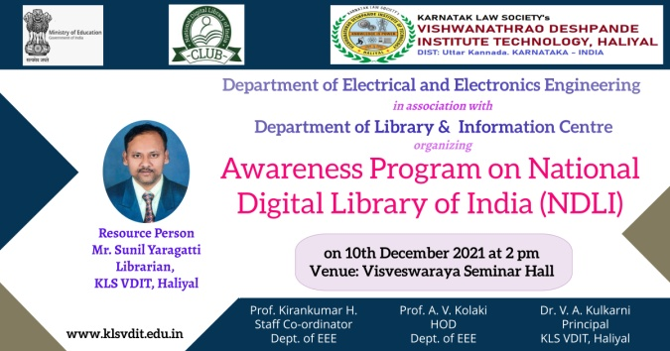 | 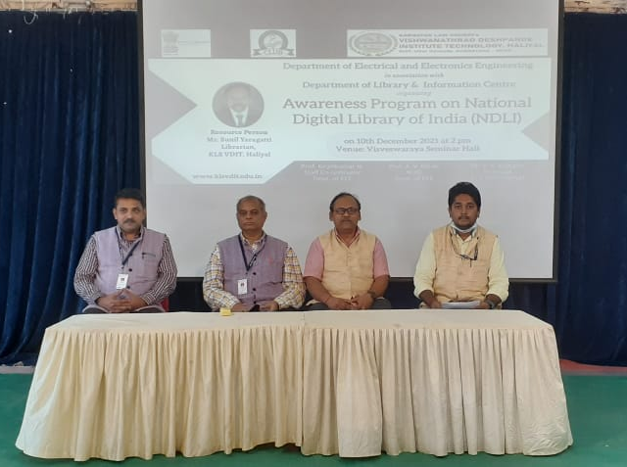
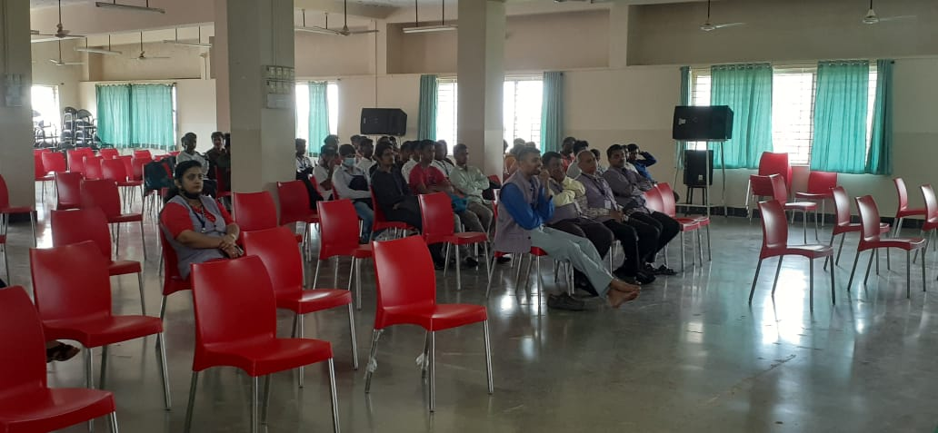 | 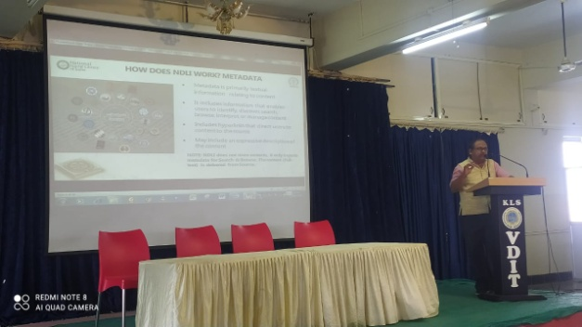

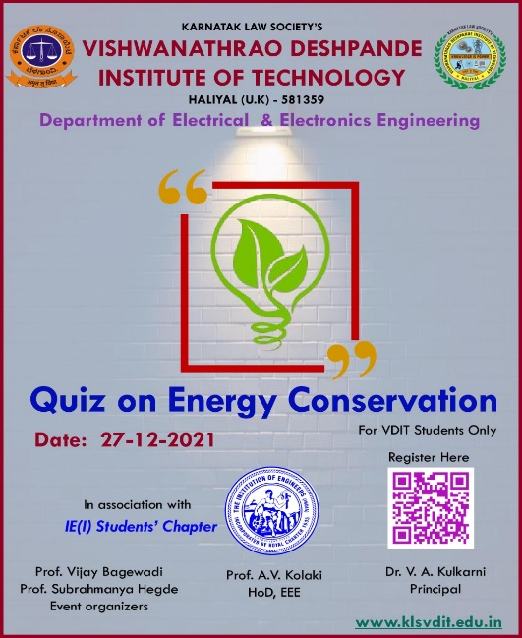
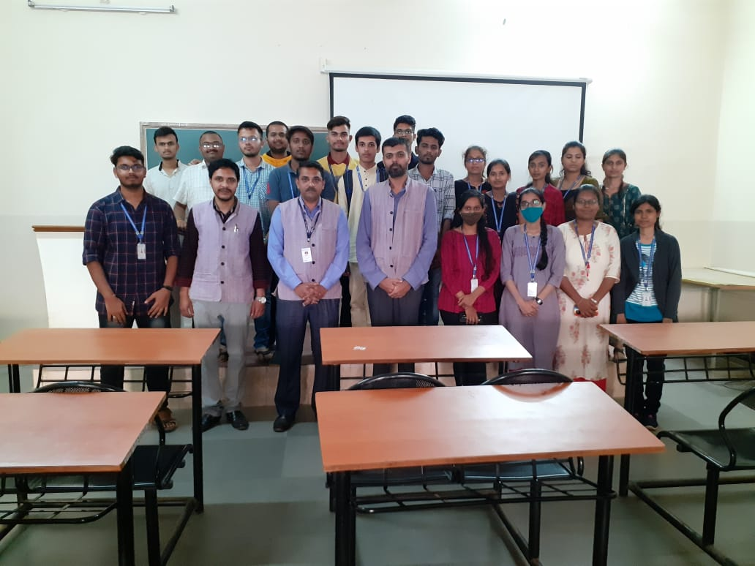
2. Department of Electrical and Electronics has organised quiz competition on “Energy conservation” 29/12/21.Which has received an overwhelming response from the students totally 46 students enrolled for the event from various branches.Prof Vijay R Bagewadi and Prof Subramanya Hegde organised the event and students co-ordinators namely Swati Joshi, Prasanna, S.Swati and Sumangala managed the smooth sailing of the proceedings.

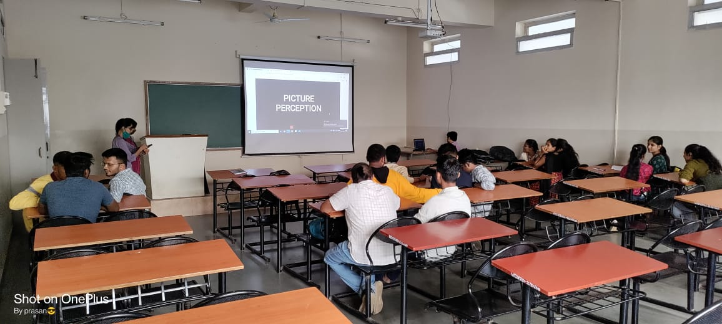

3. Prof. Varaprasad Gaonkar has completed online course on “AI for Everyone” through Coursera.

4. Mr. Pavan Bandodkar has completed one month training program on “Refrigeration and Air Conditioning” conducted by Canara Bank Deshpande Rural Self Employment Training Institute, Haliyal from 18th Nov 2021 to 17th Dec 2021.

5. Dr. Uttam S Satpute has attended One Week Training Programme on, “An Overview of Teaching Techniques in Innovation and Design Thinking”, sponsopred by AICTE-VTU Joint Training Programme on 6th- 10th Dec. 2021.

6. Prof. Subrahmanya Hegde has attended One Week Training Programme on, “An Overview of Teaching Techniques in Innovation and Design Thinking”, sponsopred by AICTE-VTU Joint Training Programme on 6th- 10th Dec. 2021.

