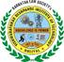 | KARNATAK LAW SOCIETY’S  Vishwanathrao Deshpande Institute of Technology
 | Doc. No.: | Rev.No.:01
 | Page 1 | Rev. Dt: 19/06/2021
 | Report on staff and student achievements from Department
Report on Events Organized by EEE Department
(February-2022)
The 3rd-semester students of the Electrical & Electronics Engineering Department accompanying Prof. Vijay Bagewadi and Prof. Kiran Hittangi had visited 110/33/11kV substation of Haliyal on 26th Feb. 2022 at 10.00 am. The visit was organized by Dr. Uttam S Satpute in support with Mr. Manjunath (Assistant Engineer Electrical, KPTCL) and Mr. Lingaraj (Junior Engineer Elect. KPTCL). Mr. Shrikant M. (AEE KPTCL) explained the single line diagram of the substation, various types of equipment involved and their functions, SCADA unit and about various feeders, etc. The visit has added practical knowledge of substation equipment and its role in the functioning of the substation. Overall the visit was good.
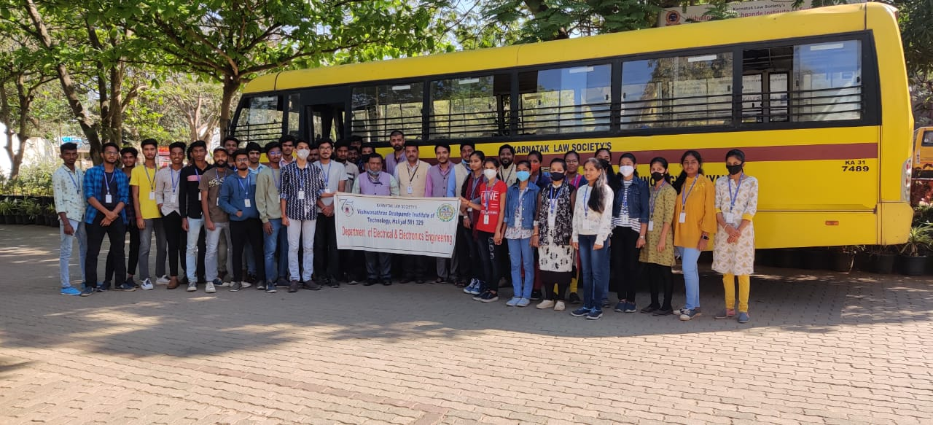
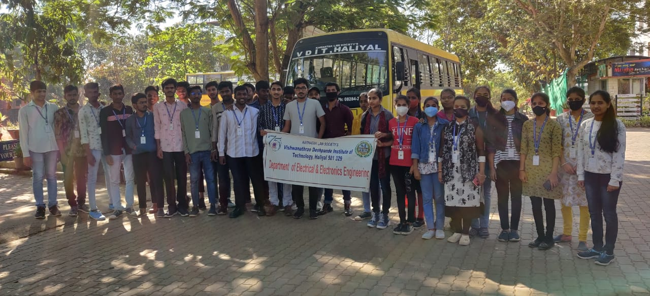
Prof. Ravindra Motekar has participated in webinar on “Advances and Benefits of Mathworks in Scientific and Engineering Endevours” organized by Department of ECE in association with ISTE Faculty Chapter held on February 01, 2022.
Prof. Ravindra Motekar has successfully participated in IP Awareness/Training program under National Intellectual Property Awareness Mission on February 10, 2022 organized by Intellectual Property Office, India.
Miss. Divya Padwalkar of 7th Sem Electrical and Electronics Engineering is awarded as VTU BLUE in Wrestling by VTU University.
Miss. Spandana Munavalli and Mr. Jahangir Ballari of 7th Sem Electrical and Electronics Engineering got placed in PRACTO.

