
Department of Electrical and Electronics Engineering
March Month achievements 2022
Placement Corner

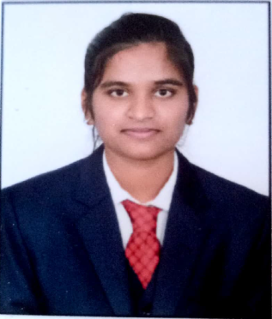
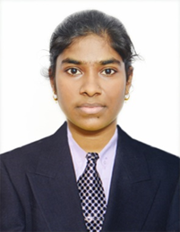
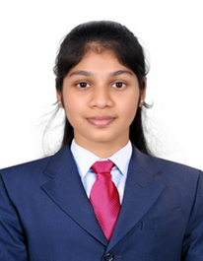
Divya P Aswini Pujar Akshata K
Company:INFOSYS Company:INFOSYS Company:CAPGEMINI
PACKAGE:3.6LPA PACKAGE:3.6LPA PACKAGE:4.5LPA
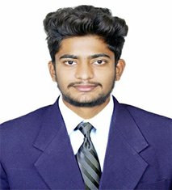
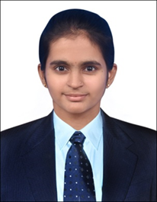

Ganesh Patil Spandana.M
Company:Wipro Company:Wipro
PACKAGE:3.8LPA PACKAGE:3.8PLA
Sports corner:
Ms.Divya Paduwalkar proud student of the EEE branch represented VTU at All India Inter University Wrestling Freestyle Women Championship 2021-2022 was held on 14th to 16th March 2022 and was organized by CHAUDHARY BANSI LAL UNIVERSITY BHIWANI , HARYANA.

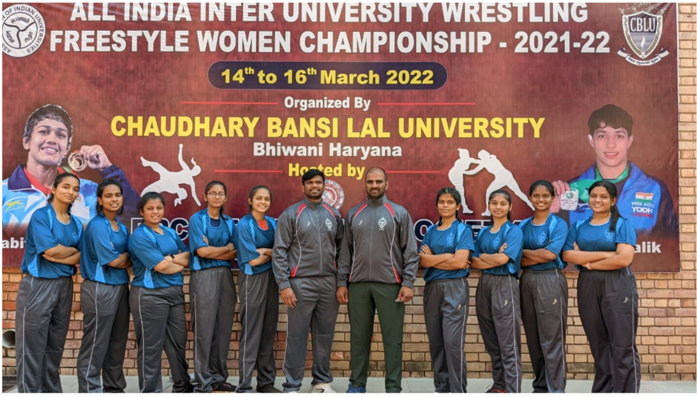

Ms. Divya Paduwalkar of EEE branch represented VTU at All India Inter University Judo Tournament was held from 22-24 March 2022 , organized by CHATRAPATI SHAHUJI MAHARAJ UNIVERSITY KANPUR UTTARPRADESH. Ms. Divya of EEE branch is VTU blue ,she bagged first prize for in JUDO and WRESTLING at university (VTU) level which was held on 16 & 17 December of 2021 at VDIT Haliyal.
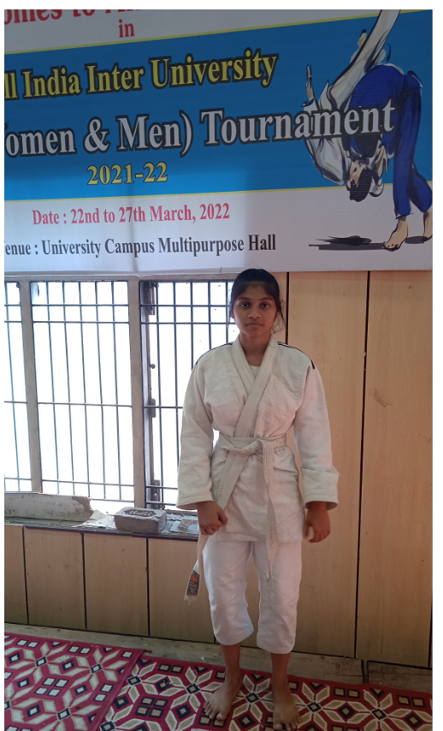
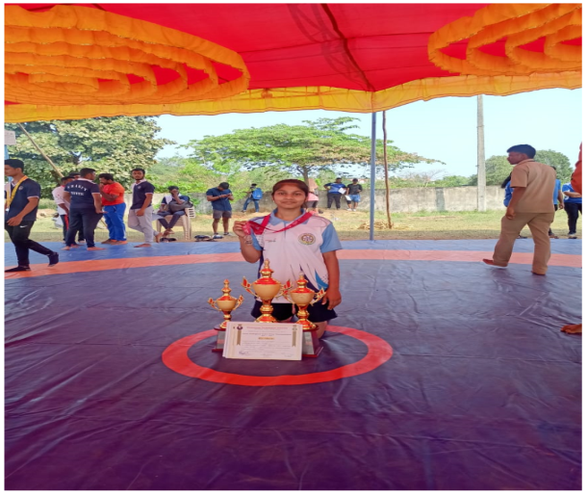

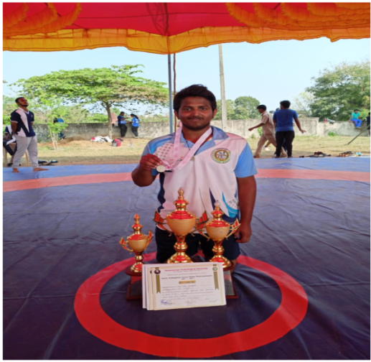
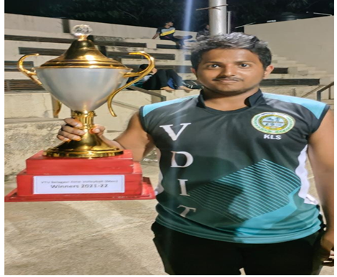

Mr. Pavankumar Madli of EEE branch participated in VTU Belgavi zone volleyball Tournament held at KLS GIT BELGAVI won the 1st place held on 29&30 November 2021.
Mr.Pavankumar Madli won second prize in VTU State level Wrestling competition held at KLS VDIT HALIYAL on 16 & 17 December 2021.

Co-Ordinator HoD Principal

