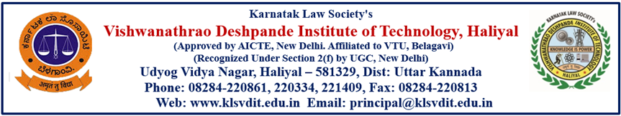
Department of Electrical and Electronics Engineering
June Month achievements 2022
Staff Name | Particulars
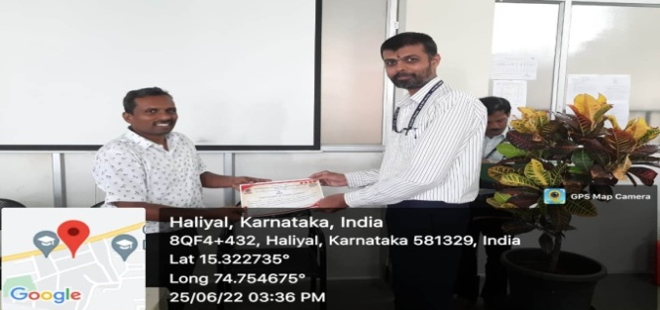  Prof.Vijay Bagewadi & Prof.S.M. Inamdar | Prof.Vijay Bagewadi & Prof.S.M.Inamdar attended Two Days Hands-on Workshop on " Computer Vision Algorithms in Autonomous Vehicles " on 24-6-2022 to 25-06-2022 organized by Department of Electronics and communication Engineering , Haliyal.
 | Prof.Vijay Bagewadi attended 5-day FDP on UHV-I (Universal Human Values) through Online mode organized by AICTE (An AICTE Initiative) from 06-06-2022 to 10-06-2022.
Dr. Uttam S Satpute | Dr. Uttam S Satpute published a paper entitled, “Design of Electric System for Offshore Wind Power Plant” in the International Journal, ‘Advances in Electrical and Electronics Engineering”, Vol 20, No.2, June 2022, Page No. 131-142.  DOI: 10.15598/aeee.v20i2.4352.

Technical Tour
1]The department of Electrical and Electronics Engineering organized a one-day Industrial visit to 220 kV Substation, Belagavi and Siddhi Vinayak Transformers, Belagavi, on 7th June 2022,43 students of 6th semester along with two teaching faculties Prof. Vasantkumar K Upadhye and Prof. Kirankumar Hittanagi visited.

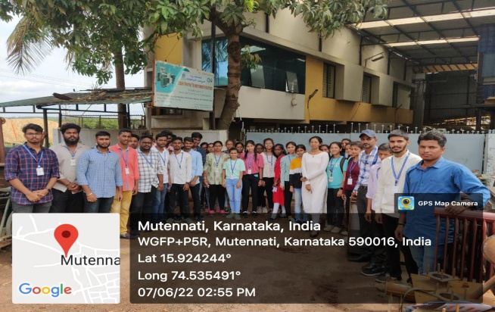

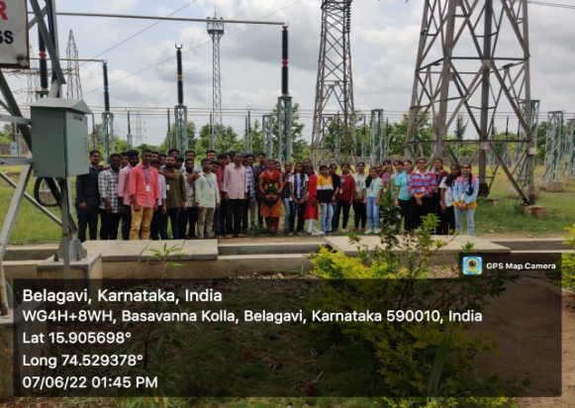

2] The Final Year students of Electrical and Electronics Engineering visited Power House ,Ganesh Gudi on 15th June 2022.The information about the working procedure of Hydal power station was explained and equipments working , their operating conditions, specifications of the devices were explained by Assistant Engineer Mr Rajendra G, of Power House, Ganesh Gudi with their colleagues.
The working of Turbine section ,Generator section and control panel of Incoming lines and Outgoing lines are explained to students. Several doubts of students were cleared by Mr Rajendra G, [A.E] and their teammates.
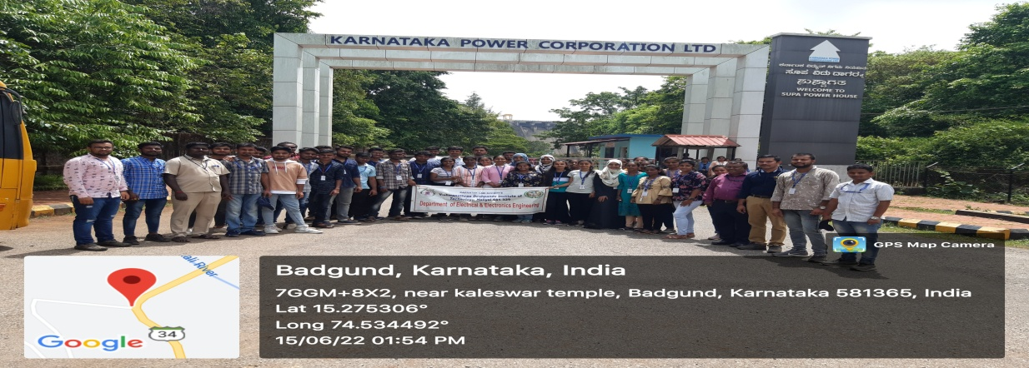

Farewell Function to (2018-2022) Batch
Department organized “Nenapinangala” a farewell function to bid adieu for final year students on 30th June 2022 at library block of VDIT campus.
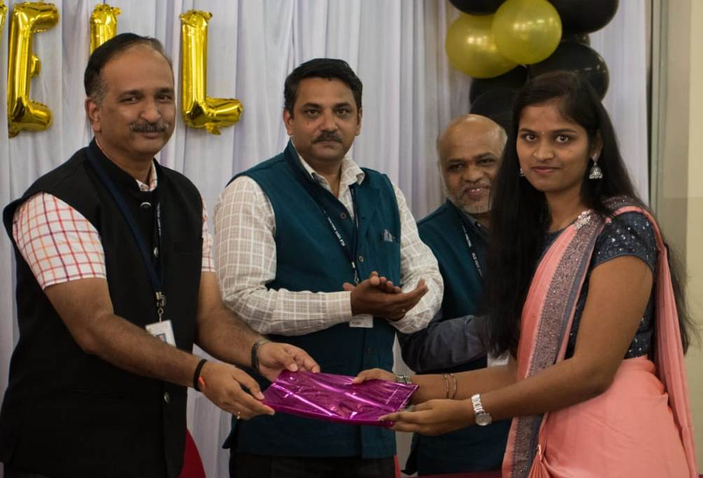
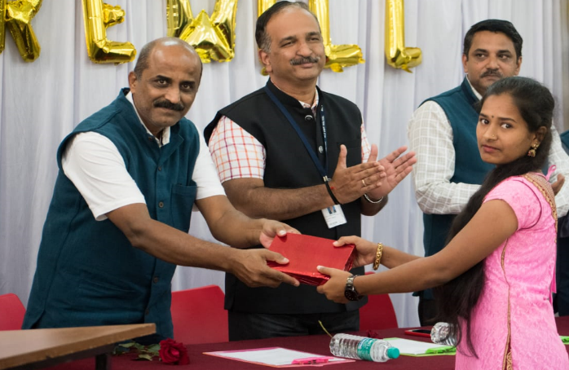

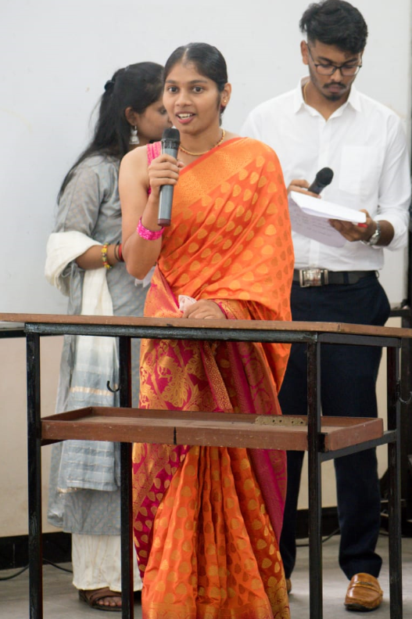
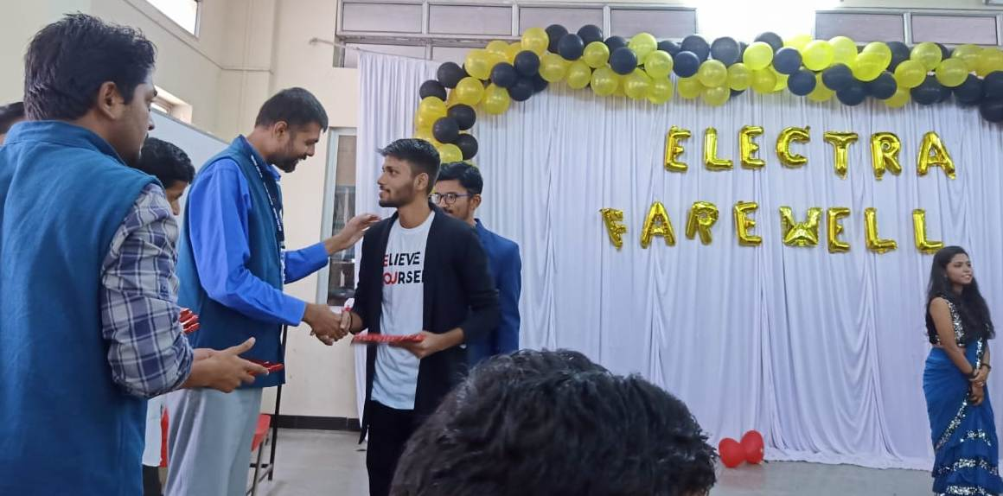

Distinguished Alumni
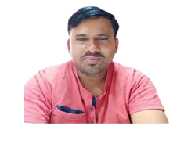
Mr. Rajendra Ghoshenatti
Assistant Engineer (Electrical)
KPCL Ganeshgudi
(Batch:2008-2011)

Mr. Rajendra Ghoshenatti started his career in Wartsila India Pvt Ltd. Maharashtra & served for one year. In 2012 he appointed as Assistant Engineer (Electrical) in Supa Power House, Ganeshgudi. Presently he is serving as Assistant Engineer (Electrical) in Supa Power House, Ganeshgudi with 10+ years of experience.
His Contribution to the Institute are,
- Participated in the Alumni meet on the eve of Foundation Day held on 11th May 2022. During the session he explained the students about how to prepare for government exams, importance of electrical domain in current scenario etc. Participated in the Induction Program as resource person Organized for the First Year students in the year 2021.

Co-ordinator HoD Principal
Prof.Vijay Bagewadi

