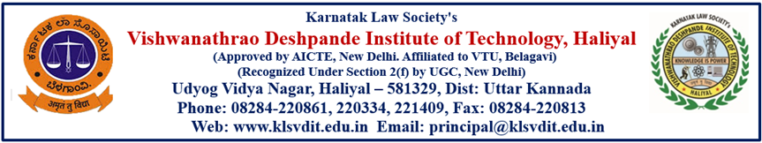
Department of Electrical and Electronics Engineering
May Month achievements 2022
Staff Name | Particulars
Sripadraj M. Inamadar | 1]Successfully completed NPTEL Online course for “Design,Technology and Innovation “ 8 week course considered as Faculty development programme [Feb-April 2022]  2]Successfully completed “PCRA-Convervation Quiz 11.0 conducted by PCRA On May 30 2022  3] Successfully completed” Smart Metering Quiz “conducted by PCRA On May 30 2022
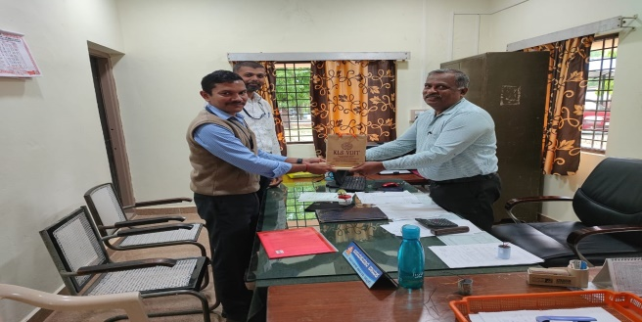 | Prof.Vijay R Bagewadi and Prof.Varaprasad Gaonkar had been to the KPCL NPH on 20th May 2022.Purpose of the visit was to procure the scrapped electrical equipment of KPCL(Ambika Nagar NPH) to the department exhibition centre.

Students Achievements
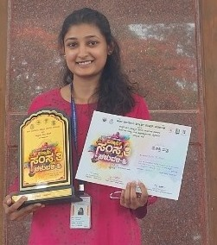
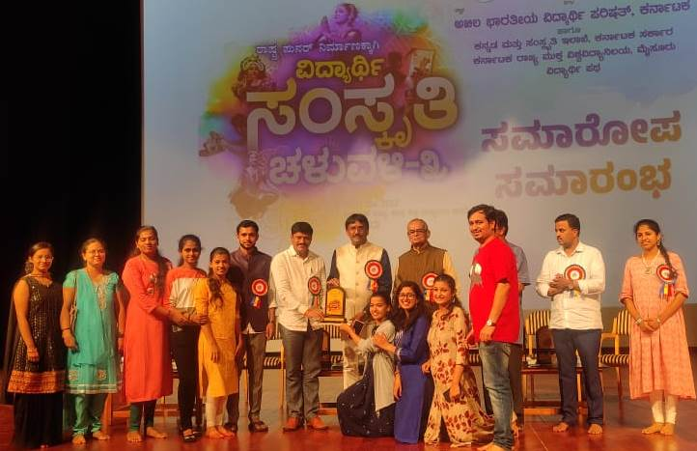

Shravani Joshi, Of VI Sem won the second prize in classical group dance ,state level competition in ‘Sanskrutika Chaluvalli’ event held on14th May 2022 at Mysuru.

Distinguished Alumni
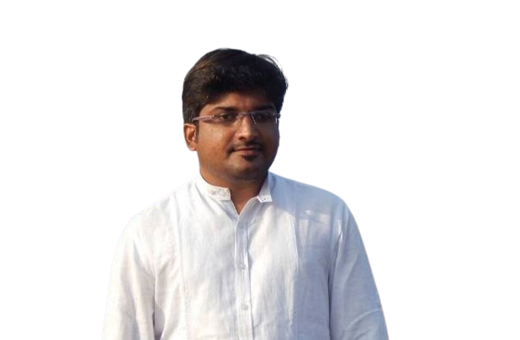

Mr. Tirumal Naik
Assistant Engineer
KPCL Ganeshgudi

Mr. Tirumal Naik completed his graduation in Electrical & Electronics Engineering from KLS VDIT Haliyal in 2009.He started his career as Assistant Engineer in KPCL Ganeshgudi. He has 13 years of work experience as Assistant Engineer (Electrical). Presently he is serving as Assistant Engineer in KPCL Ambikanagar.

His Contribution to the Institute are,
Participated in the Alumni meet on the eve of Foundation Day held on 11th May 2022. During the session he addressed the students about preparation for government exams, importance of electrical domain etc.

Alumnus Home coming
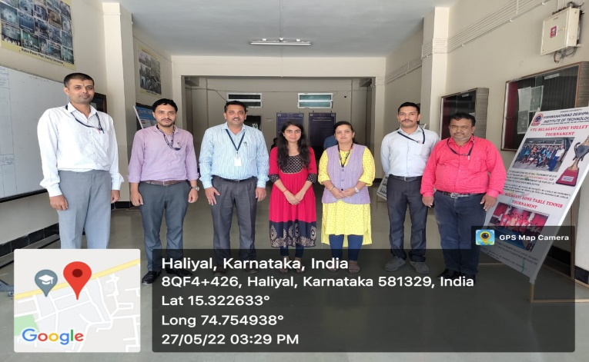

Ms. Poornima Korvekar
Executive Engineer
L&T Technology Service

Ms. Poornima Korvekar our proud alumnus visited the department on 22nd May 2022, shared her working nature and type of task she is doing at L&T Technologies and eager to guide the students.

Alumni Event Report
On the eve of 17th Foundation Day of Karnatak Law Society’s Vishwanathrao Deshpande Institute of Technology Haliyal, department of Electrical & Electronics Engineering has organized a Alumni Meet. 7 alumni’s working in the various sectors has witnessed the event. During the event an interaction session was conducted between 6th, 8th semester students of the department & alumnus. Alumnus shared their journey after their graduation & present market scenario.
Following were the key points of interaction
- Maintaining the CGPA as per requirement.
- Learn the things practically rather than mugging,
- Importance of Internship, undergoing the online courses during vacation period.
- Knowledge of programming languages like C, C++, Java, Python etc.,
- Preparation for government exams like, KPCL, KPTCL.
All the department faculties & more than 60 students were present during the event. Students expressed their positive response for the event.
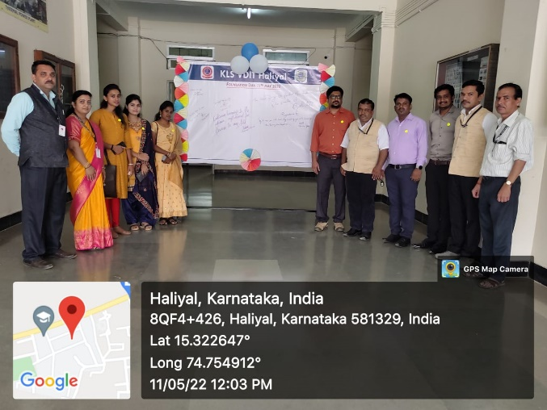 | 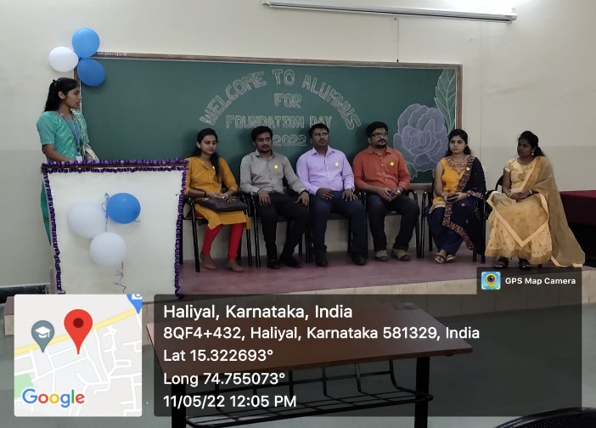
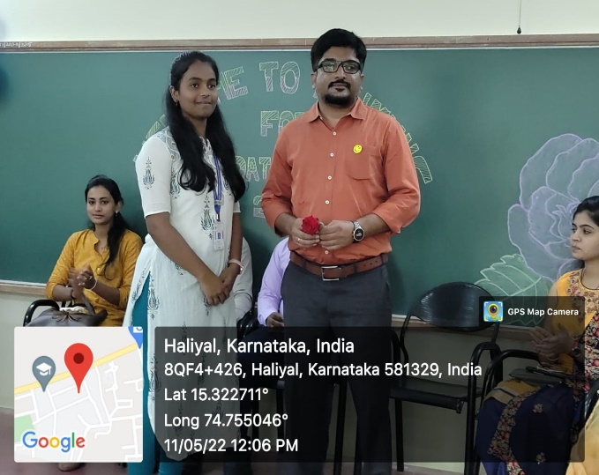 | 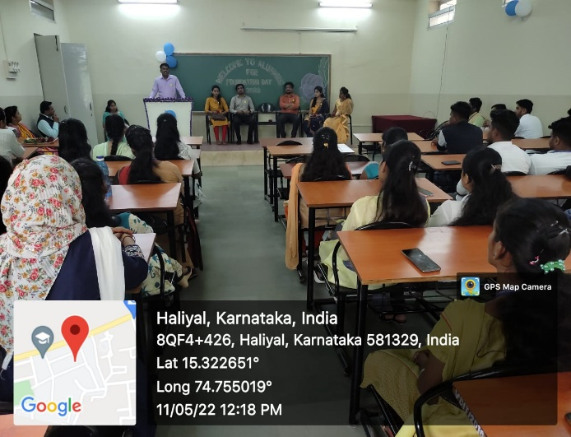
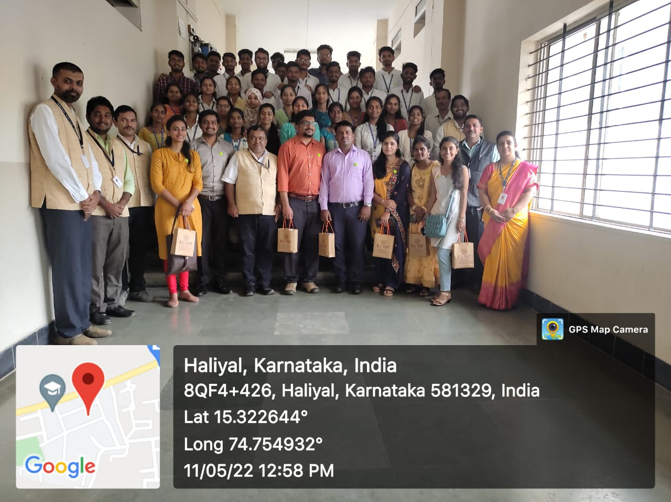

Co-Ordinator HoD Principal
Prof.Vijay Bagewadi

